**Assignment 1: Software installation**

* **Script 1:** Write a program to install the **curl** package on different Linux distros(debain, redhat, alpine). Use the **case** condition in the program,to check/install package. The program should exit with the stderr "Distro not identified" if the OS is different than the list.

Input

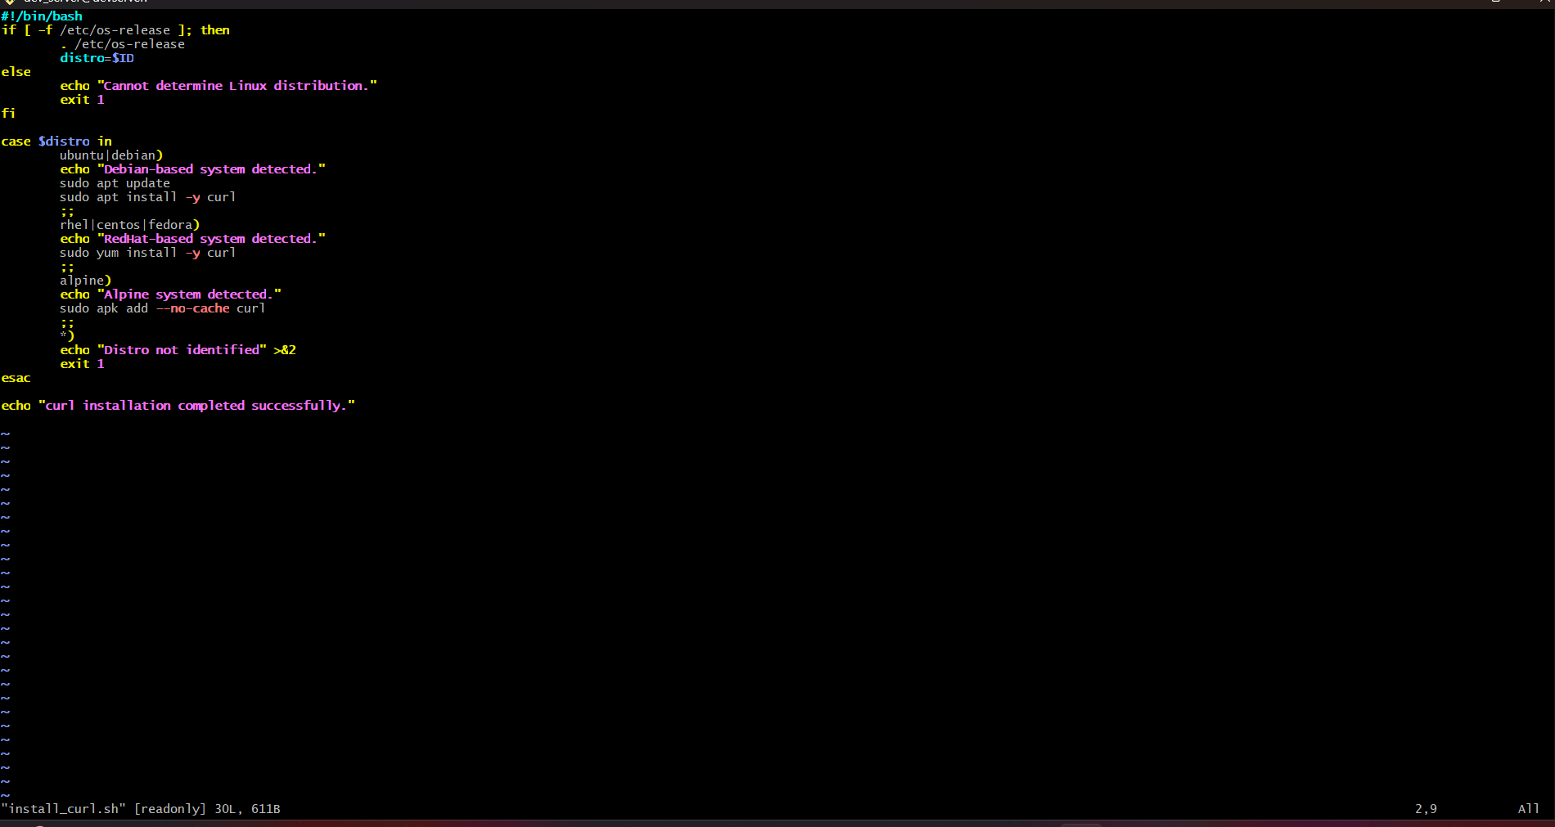

Output

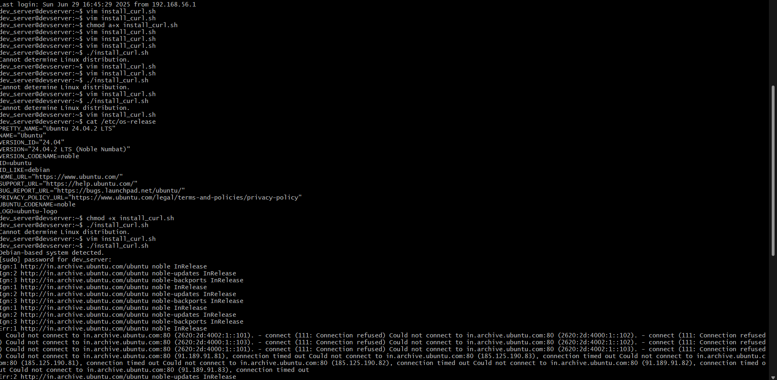

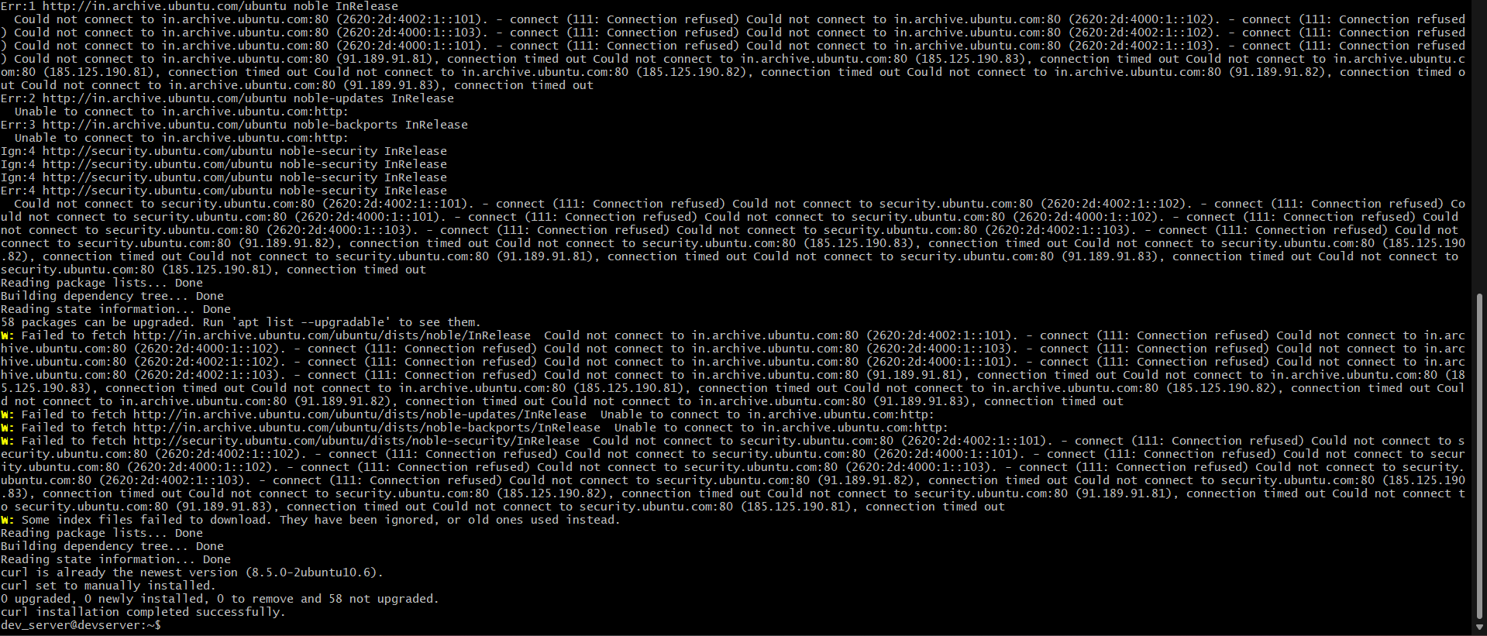

**Assignment 2: File Operations**

* **Script 1:** Write a script that takes a directory path as an argument and lists all the files in that directory.
* **Script 2:** Create a script that renames all files in a directory with a **.txt** extension to have a prefix **"backup_"** (e.g., **file.txt** becomes **backup_file.txt**).
* **Script 3:** Write a script that takes two file paths as arguments and compares them. If they are identical, print a message saying so; otherwise, display the differences

Script1

Input code

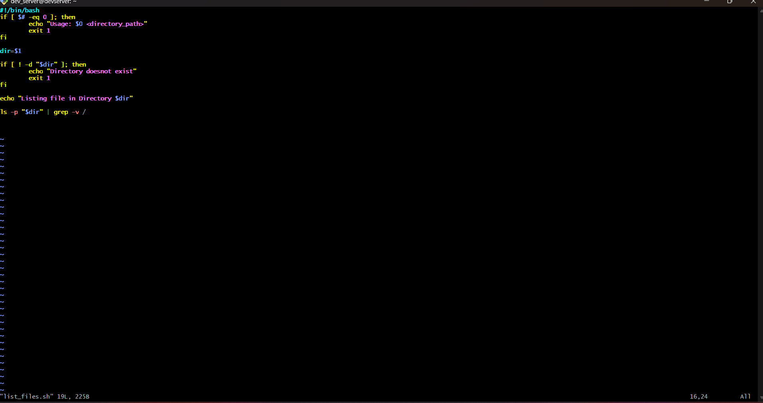

Output +ve and negative

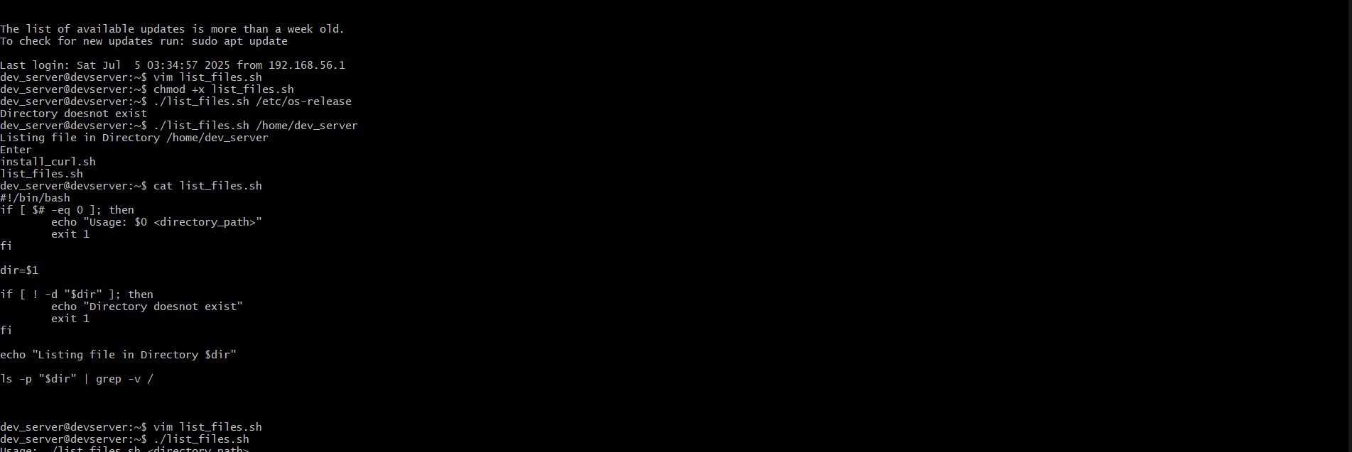

Script 2

Input

-------------------

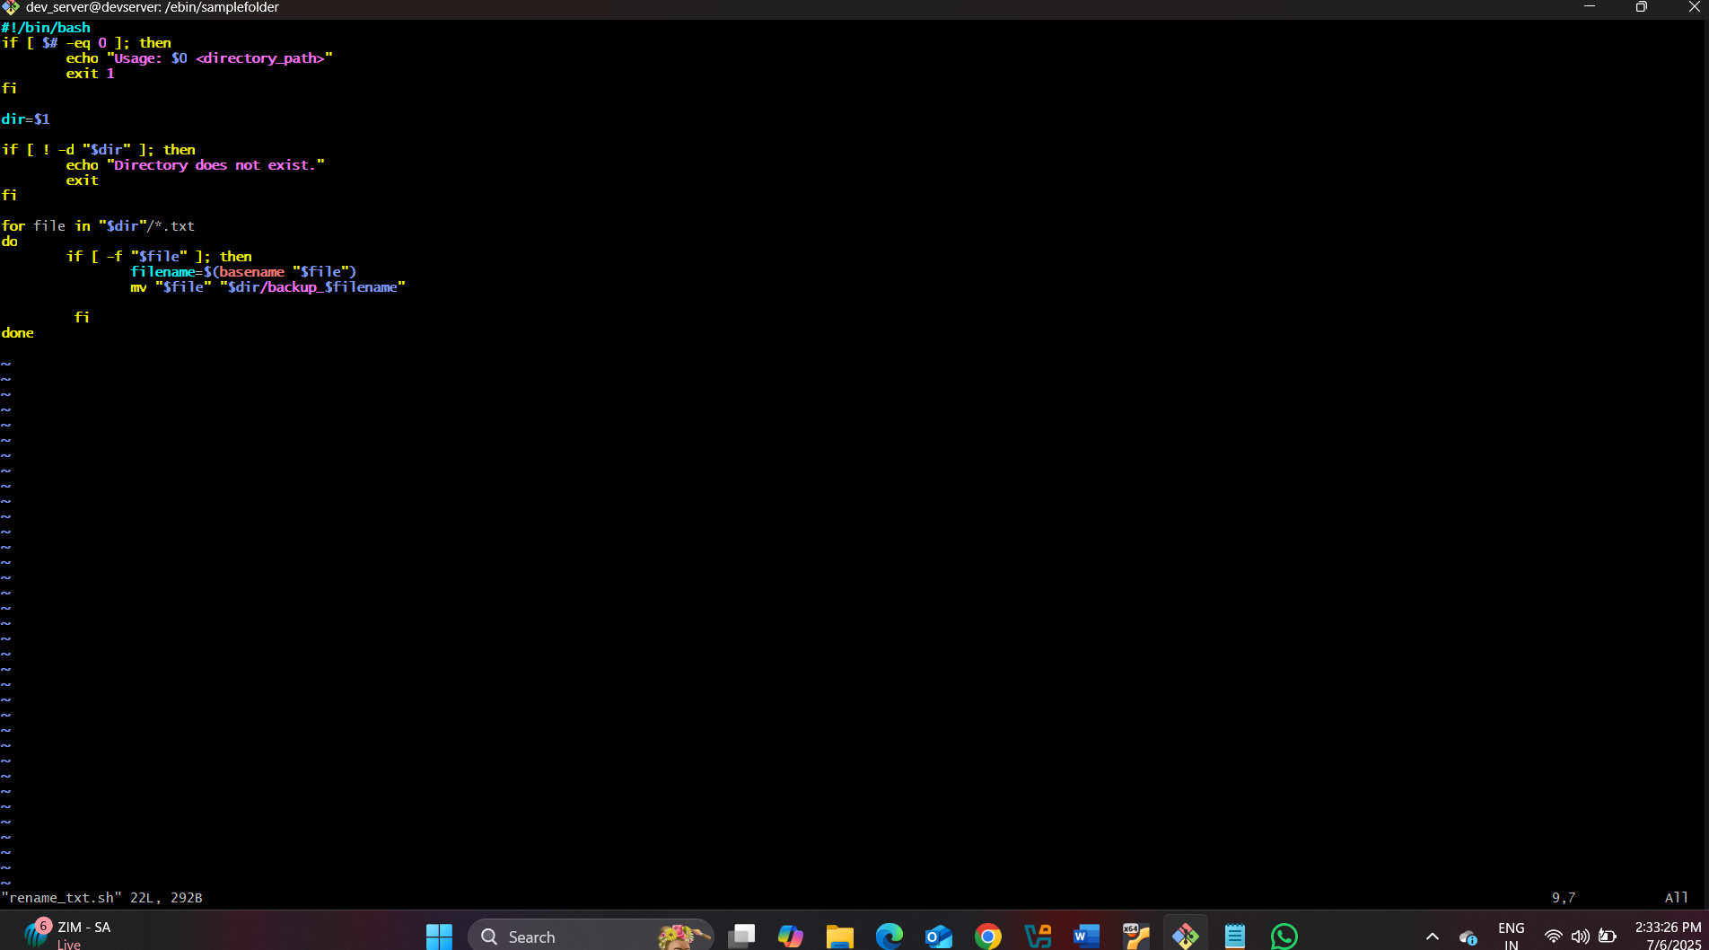

Output

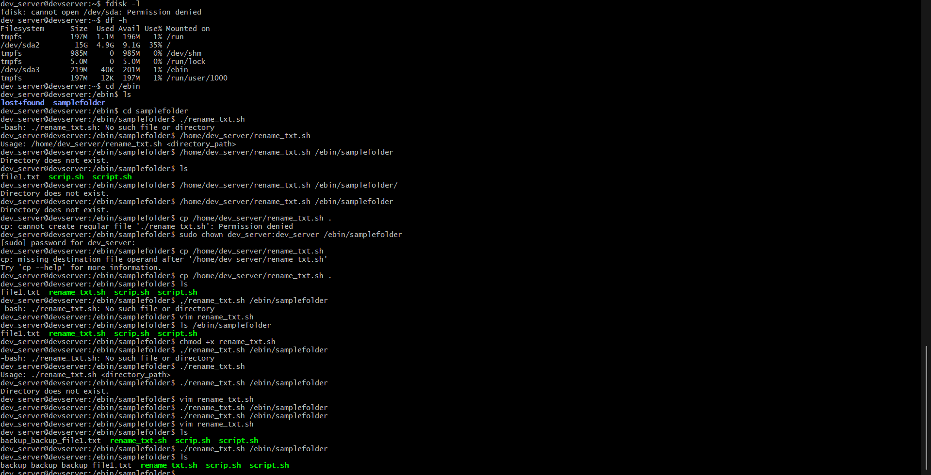

Script 3

Input code

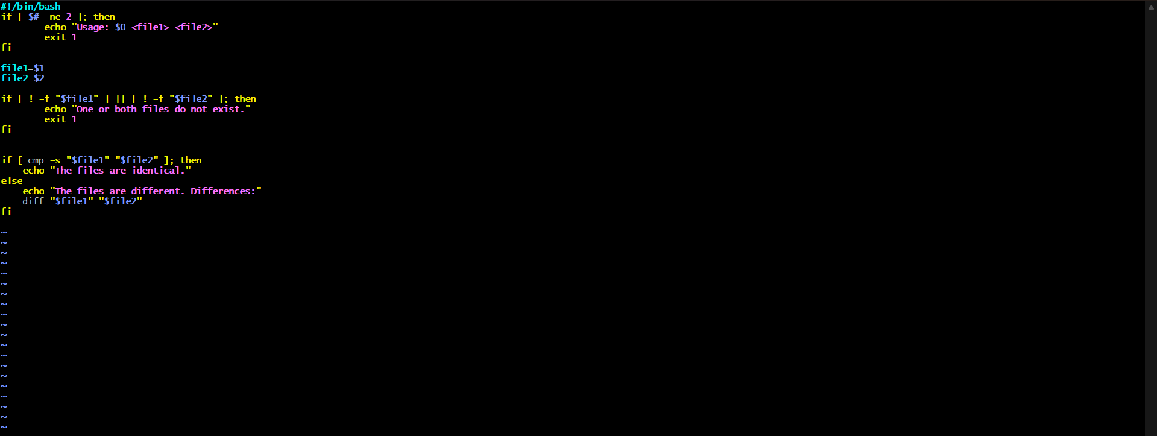

Output

